**MAX FILTER - MATLAB CODE**

* To find the brightest points in an image.
* Finds the maximum value in the area encompassed by the filter.
* Reduces the pepper noise as a result of the max operation.
* The 100th percentile filter is max filter. Check the 50th percentile filter i.e the [median filter](http://angeljohnsy.blogspot.in/2011/03/2d-median-filtering-for-salt-and-pepper.html).

[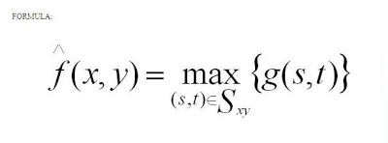](https://3.bp.blogspot.com/-eXCepEGo1mo/UXVv6LYhp_I/AAAAAAAAAzI/SPrameAumQA/s1600/form_max_filter.jpg)

[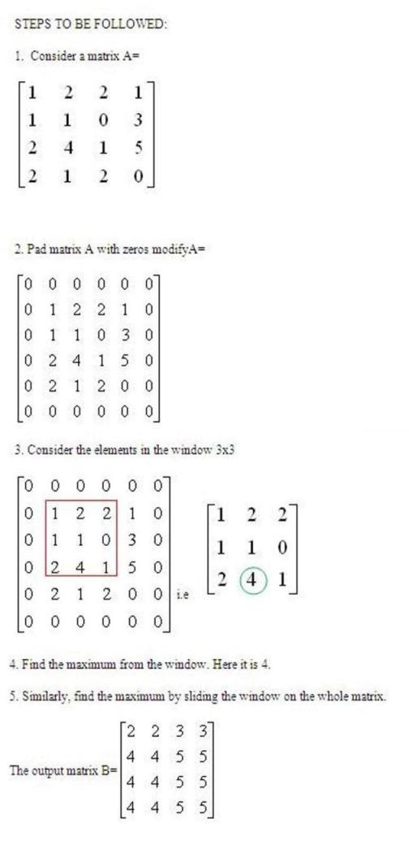](https://1.bp.blogspot.com/-rVNuus3rlM8/UXVymrCutcI/AAAAAAAAAz0/lV_-Br4_9fs/s1600/steps01_max.jpg)

[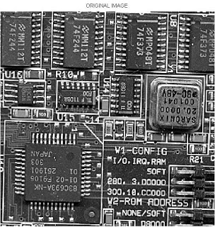](https://3.bp.blogspot.com/-ngraYgBlf6A/UXVw3fEMs9I/AAAAAAAAAzo/FLRDqAbMYgM/s1600/max_input.jpg)

[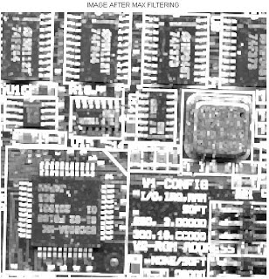](https://4.bp.blogspot.com/-4uwNaKgMBA8/UXVw28rsl1I/AAAAAAAAAzg/TfJDJCbrbsk/s1600/max_filter_res.jpg)